**Week-1**

**Design Patterns and Principles**

**HandsOn**

**Exercise 1: Implementing the Singleton Pattern**

**Scenario:**

You need to ensure that a logging utility class in your application has only one instance throughout the application lifecycle to ensure consistent logging.

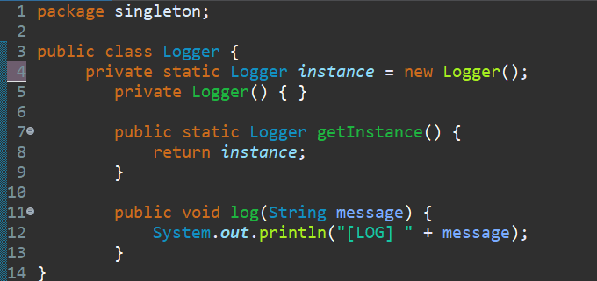**class Logger:**

**class SingletonTest:**

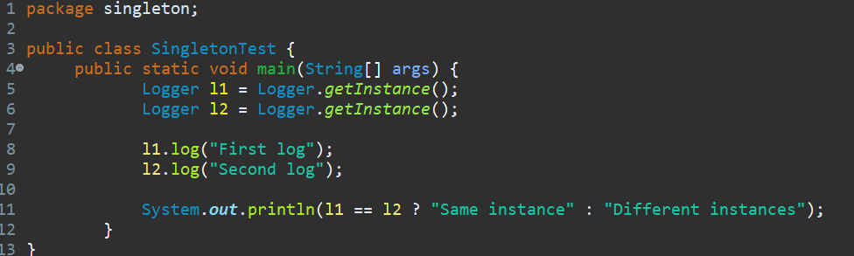

**Output:**

